



Super StarWars Process API

Super Organization

v1.0, 2024-05-16

| **Version** | **Date** | **Author** | **Description** |
| --- | --- | --- | --- |
| 1.0 | 2024/05/16 | Kevin Jonathan Medina Resendis | Initial version |

Table of contents

Introduction 2

Audience 3

Glossary 3

References 3

Use-case overview 3

Assumptions 5

Prerequisites 5

Business Requirements 5

Technical Design 6

Overview 6

Logical View 6

Components/Mule Applications 6

Non-Functional Requirements 7

Security 7

Common NFR 7

Super StarWars Process API 8

Mule Application Details 8

Resources 10

GET: /characters 10

RAML Specification Details 10

Flow Process: 13

Error Process 34

Logs 35

Unit Test Cases 35

Positive Test Cases 35

Negative Test Cases 36

Installation Requirements 36

Backend System 36

Mule Components 37

Non-Mule Components 37

Firewall Requirements 37

Monitoring 37

# Introduction

This document defines the technical components to implement the proposed API/Integration solution.

## Audience

This document’s audience primarily includes architects, consultants, developers, and testers engaged in architecting, designing, developing, and testing API-based solutions.

## Glossary

The general terms and acronyms referenced in this document

## References

*<TBD>*

# Use-case overview

Super StarWars Process API provides the functionality to retrieve the data related to the characters from the movie franchise by processing SWAPI API Pagination Results and formatting to CSV Format.

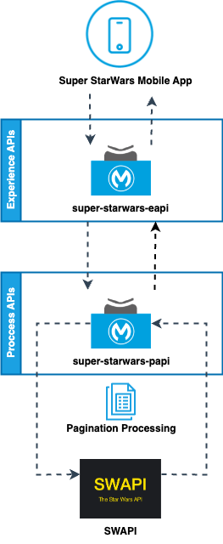

## Assumptions

This section covers any assumptions that have been made in the process of designing the solution.

* SWAPI API is a public API and no authentication process is needed.

## Prerequisites

This section covers any prerequisites that are required as part of the solution.

* NA

## Business Requirements

This section captures high-level requirements as part of the solution.

* Business needs all the characters information in CSV Format to be used and compared by the Super StarWars Mobile Application users.
* Business needs a filter that can be applied to the characters information based on the character gender.

# Technical Design

This section captures the technical design details of the solution.

## Overview

Mulesoft Super StarWars Experience API will invoke super-starwars-papi to check starwars characters information and share it with consumers of Super StarWars Mobile Application.

## Logical View

The sequence diagram is too big to be shown in the document and will be added to a folder and be part of the documentation.

## Components/Mule Applications

| **Mule Applications** | | | |
| --- | --- | --- | --- |
| S.No | Application Name | Type | Description |
| 1 | super-starwars-papi | API | Super StarWars Experience API |
| 2 | SWAPI(StarWars API) | API | Public StarWars API |

# 

# Non-Functional Requirements

This section captures the non-functional requirements of all APIs related to the use-case(s)/solution.

## Security

| **Authentication** | | |
| --- | --- | --- |
| S.No | Application Name | Authentication Type/Policy |
| 1 | super-starwars-papi | Client ID Enforcement Policy |
| 2 | SWAPI | No Authentication |

## Common NFR

NA

**HTTP/Web service**

**Properties for API**

| Reconnection Frequency | 2000 milliseconds |
| --- | --- |
| Reconnection Max Attempts | 2 |
| HTTP Timeout | 15000 milliseconds |

# Super StarWars Process API

## Mule Application Details

| **API Overview** | | |
| --- | --- | --- |
| S.No | Property | Details |
| 1 | Application Technical Name | super-starwars-papi |
| 2 | Application Business Name | Super StarWars PAPI |
| 3 | Aliases | Super StarWars PAPI |
| 4 | Mule Application Type | API |
| 5 | API Type | Process |
| 6 | Business Domain | Mobile App |
| 7 | Purpose of API | The Super Star Wars API will retrieve the data related to the characters from the movie franchise. |
| 8 | API Owner | Super Organization Dev Team |
| 9 | Version(s) | v1 |
| 10 | Initial Release Date (optional) | May 17th, 2024 |
| 11 | app.url.name | TBD |
| 12 | Source Code Repo | TBD |

| **Health-check/Ping end-point** | |
| --- | --- |
| Endpoint | GET {BASE_URI}/api/v1/healthcheck |
| Success | Return a **200** upon receipt of a request on the /healthcheck end-point with the next body: {  "status": "OK",  "dependencies":[  {  "name": "SWAPI",  "status": "OK"  }  ]  } |
| HTTP Status Code | Possible HTTP status codes for the response include:   * 200 Request accepted * 401 Unauthorized – for errors in an API authentication * 500 Internal Server Error – for unexpected failures |

## Resources

| **Resources** | | | |
| --- | --- | --- | --- |
| S.No | Resource Name | Supported Methods | Description |
| 1 | /healthcheck | GET | This Resource will retrieve application status.  Media Type: application/json |
| 2 | /characters | GET | This Resource will retrieve StarWars characters information consuming SWAPI API Pagination Results, this information could be filtered based on gender.  Media Type: application/csv |

## GET: /characters

Retrieve characters information

### RAML Specification Details

| **Input Request** | | | |
| --- | --- | --- | --- |
| Name | Type | Mandatory | Comments |
| gender | Query Param | No | Possible Values:   * male * female * unknown * n/a(for robots) |
| hypermediaSearch | Query Param | No | Possible Values: yes, no. |

| **Response** | | | |
| --- | --- | --- | --- |
| Name | Type | Mandatory | Comments |
| name | String | Yes |  |
| height | String | Yes |  |
| mass | String | Yes |  |
| hair_color | String | Yes |  |
| skin_color | String | Yes |  |
| eye_color | String | Yes |  |
| birth_year | String | Yes |  |
| gender | String | Yes |  |
| homeworld | String | No | *This applies only if the hypermediaSearch query parameter is sent.* |
| films | String | No | Films will be put together in a single string separated by a comma. *This applies only if the hypermediaSearch query parameter is sent.*  *Ex. movie1, movie2, …..* |
| species | String | No | Species will be put together in a single string separated by a comma. *This applies only if the hypermediaSearch query parameter is sent.*  *Ex. specie1, specie2, …..* |
| vehicles | String | No | Vehicles will be put together in a single string separated by a comma. *This applies only if the hypermediaSearch query parameter is sent.*  *Ex. vehicle1, vehicle2, …..* |
| starships | String | No | Starships will be put together in a single string separated by a comma. *This applies only if the hypermediaSearch query parameter is sent.*  *Ex. starship1, starship2, …..* |
| created | String | No | Date Format: "YYYY-MM-DDTHH:mm:ss.ssssssZ" *This applies only if the hypermediaSearch query parameter is sent.* |
| edited | String | No | Date Format: "YYYY-MM-DDTHH:mm:ss.ssssssZ"  *This applies only if the hypermediaSearch query parameter is sent.* |
| url | String | No | *This applies only if the hypermediaSearch query parameter is sent.* |

| **API Response Body Structure** | | |
| --- | --- | --- |
| HTTP Code | / Format | Structure |
| *200 OK* | *application/csv* | **Basic Search Response:** name,height,mass,hair_color,skin_color,eye_color,birth_year,gender  C-3PO,167,75,n/a,gold,yellow,112BBY,n/a  R2-D2,96,32,n/a,white\, blue,red,33BBY,n/a  R5-D4,97,32,n/a,white\, red,red,unknown,n/a  **Hypermedia Search Response:** name,height,mass,hair_color,skin_color,eye_color,birth_year,gender,homeworld,films,species,vehicles,starships,created,edited,url  C-3PO,167,75,n/a,gold,yellow,112BBY,n/a,Tatooine,A New Hope\, The Empire Strikes Back\, Return of the Jedi\, The Phantom Menace\, Attack of the Clones\, Revenge of the Sith,Droid,,,2014-12-10T15:10:51.357000Z,2014-12-20T21:17:50.309000Z,https://swapi.dev/api/people/2/ |
| *400*  *Bad Request* | *application/json* | { "status": "ERROR",  "code": "400",  "message": "Bad Request", "context": "Detailed Description Error" } |
| *401 Unauthorized* | *application/json* | “Unauthorized or invalid client application credentials” |
| *404 Not Found* | *application/json* | { "status": "ERROR", "code": "404", "message": "Not Found", "context": "Detailed Description Error" } |
| *500* *Internal Server Error* | *application/json* | { "status": "ERROR", "code": "500", "message": "Internal Server Error", "context": "Detailed Description Error" } |

### **Project Structure:**

Prepare the Project by following the next structure:

* super-starwars-papi.xml(main file)
* Common folder
* Implementation folder
* Under src/resources add:
  + Properties folder
  + Dw folder

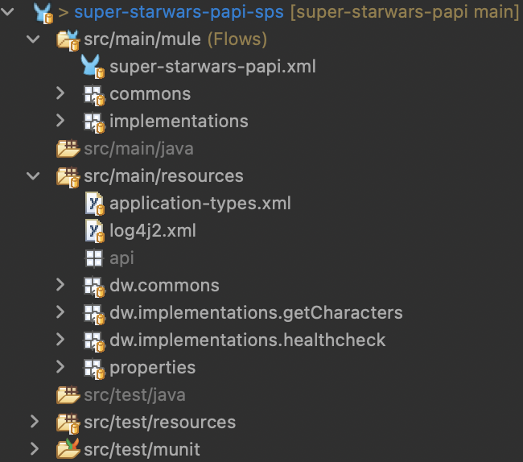

Create a new file **global.xml** to add all the API global configurations:

* OPTIONAL, put the file in the common folder(create a folder if it doesn´t exist).
* Move the **HTTP Listener Configuration** from **super-starwars-papi.xml**l file to **global.xml.**
* Move the **APIKit Configuration** from **super-starwars-papi.xml** file to **global.xml.**

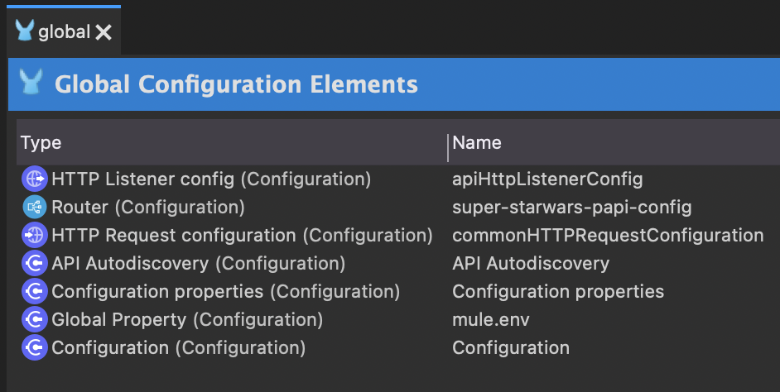

### **Flow Process get healthcheck:**

Add a Flow-Reference to the **get:\healthcheck:super-starwars-papi-config** Flow and configure it to call the **get-healthcheck-flow.**

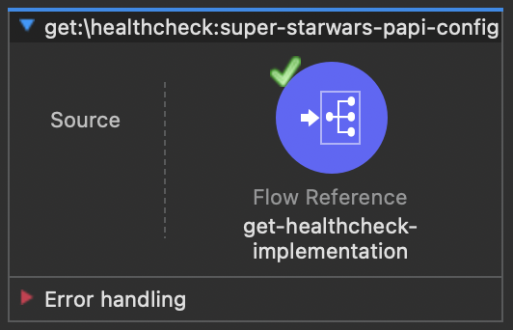

Create a new file **get-healthcheck-implementation.xml** in the implementation folder(create a folder if it doesn´t exist). This file will contain the following flows:

* Get-healthcheck-flow

Inside **get-healthcheck-flow:**

* Add a Transform Message and set the **httpRequest** variable.
* Add a **Try Scope:**
  + Inside Try:
    - add a Flow-Reference and configure it to call common flow **common-http-request-flow**. This flow reference will use the **httpRequest** variable.
    - Add a Transform Message and set the **healthcheck** response for OK scenario.
  + Inside Catch:
    - .Add On-Error-Continue, inside the error scope:
      * Add a Transform Message and set the **heathcheck** response for DOWN scenario

### **Flow Process get characters:**

Add a Flow-Reference to the **get:\characters:super-starwars-papi-config** Flow and configure it to call the **get-characters-flow.**

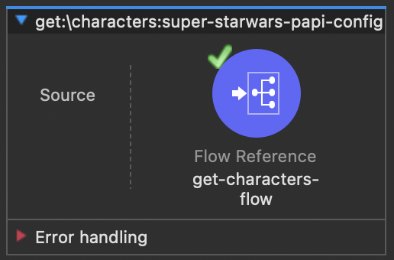

Create a new file **get-characters-implementation.xml** in the implementation folder(create a folder if it doesn´t exist). This file will contain the following flows:

* Get-character-flow
* Get-characters-first-page-subflow
* Get-characters-pagination-subflow

Inside **get-characters-flow**:

* Add a logger and print a message to indicate the process is getting started.
* Add a Flow-Reference and configure it to call get-characters-first-page-subflow.
* Add a Flow-Reference and configure it to call get-characters-pagination-subflow.
* Add a Choice-Router and configure it to validate if the query parameter hypermediaSearch is present:
  + If the parameter is present, add a Flow-Reference and configure it to call get-characters-hypermedia-flow. This flow reference will use pagination accumulator results and perform a deep search to retrieve hypermedia data for each one of the results.
  + If the parameter is absent, add a Transform Message and map the pagination results as the payload response to CSV format. This is a ***Basic Search*** process. The request process ends here.
* Add a logger and print a message to indicate the process ended.

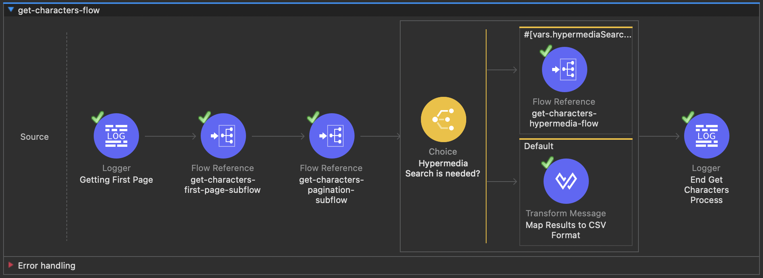

Inside **get-characters-first-page-subflow**:

* Add a Transform Message and set 4 set variables:
  + **hypermediaSearch**: stores a query parameter indicating if a hypermedia search is needed.
  + **gender**: stores a query parameter that will help us filter the results based on the character's gender if required.
  + **paginationAccumulator**: create an empty array, this variable will store all the results from all the calls to SWAPI API /people.
  + **httpRequest**: stores a common JSON object to send a request to the common-http-request component.
* Add a Flow-Reference and configure it to call common flow **common-http-request-flow**. This flow reference will use the httpRequest variable created in previous step.
* Add a Transform Message and update the **paginationAccumulator** variable with the HTTP response from SWAPI API, results are from page-1 iteration. Results will be filtered if the gender variable is present.

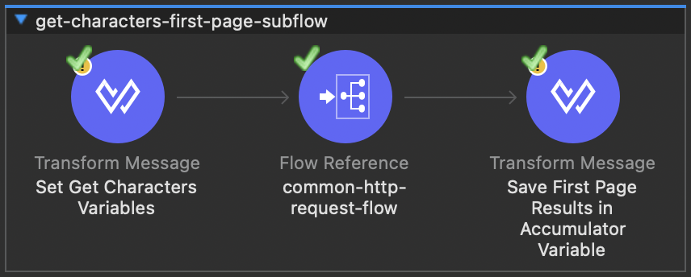

Inside **get-characters-pagination-subflow**:

* Add a Choice-Router to validate if a pagination process is needed:
  + If there are **more mages** to process:
    - Add a Transform Message and set 1 variable:
      * **Pages**: stores array that will save the number of pages to be processed.
    - Add a Parallel For Each to iterate the pages saved in the pages variable, inside the for each scope we will follow the next steps:
      * Add a logger to print the current page in iteration.
      * Add a Transform Message and update the **httpRequest** variable by adding the “page” query parameter to the common JSON object, the “page” value will be the current page in iteration.
      * Add a Flow-Reference and configure it to call common flow **common-http-request-flow**. This flow reference will use the httpRequest variable updated in the previous step.
      * Add a Transform Message and update **paginationAccumulator** variable with the Parallel For Each result(accumulated HTTP Responses from SWAPI API pages calls). Results will be filtered if the gender variable is present.
  + The **default** route: add a logger to print a message to indicate no more pages were found.

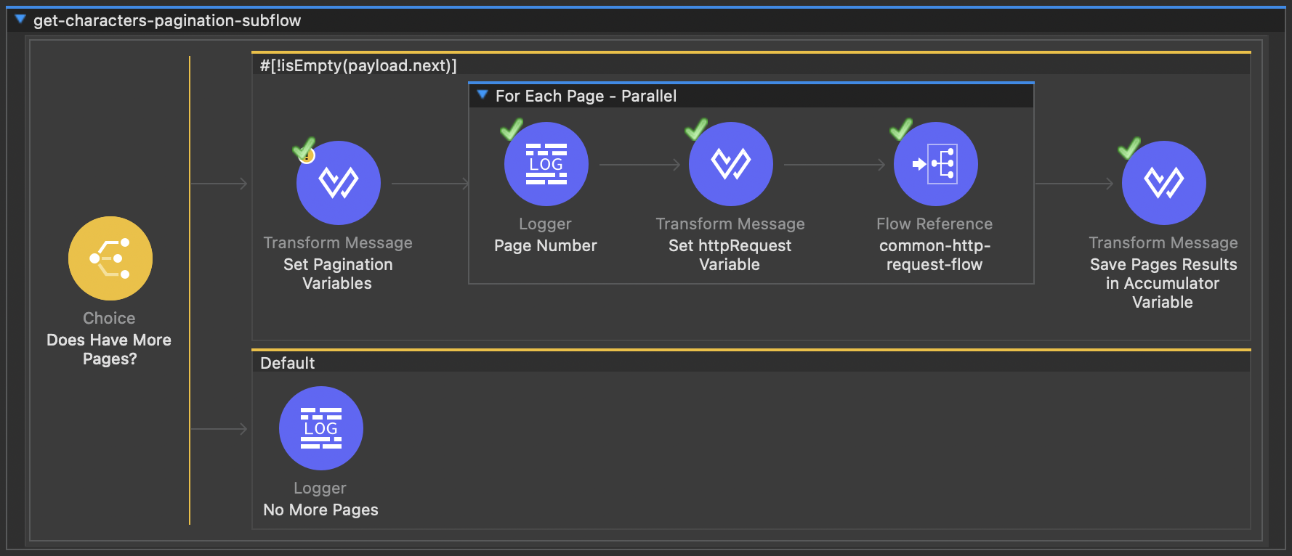

Create a new file **get-characters-implementation.xml** in the implementation folder(create a folder if it doesn´t exist). This file will contain the following flows:

* Get-characters-hypermedia-flow
* Get-characters-homeworld-subflow
* Get-characters-films-subflow
* Get-characters-species-subflow
* Get-characters-vehicles-subflow
* Get-characters-starships-subflow

Inside **get-characters-hypermedia-flow:**

* Add a logger and print a message to indicate the hypermedia process is getting started.
* Add a Parallel For Each to iterate the results saved in the **paginationAccumulator** variable, inside the for each scope we will follow the next steps:
  + Add Flow-Reference and configure it to call **get-characters-homerworld-subflow.** This flow reference will use the current **payload.homeworld** of the current character payload in iteration
  + Add Flow-Reference and configure it to call **get-characters-films-subflow.** This flow reference will use the current **payload.films** of the current character payload in iteration.
  + Add Flow-Reference and configure it to call **get-characters-species-subflow.** This flow reference will use the current **payload.species** of the current character payload in iteration.
  + Add Flow-Reference and configure it to call **get-characters-vehicles-subflow.** This flow reference will use the current **payload.vehicles** of the current character payload in iteration.
  + Add Flow-Reference and configure it to call **get-characters-starships-subflow.** This flow reference will use the current **payload.starships** of the current character payload in iteration.
* Add a Transform Message and map the For each result as the **payload response** to CSV Format. This is a ***Hypermedia Search*** process. The request process ends here.

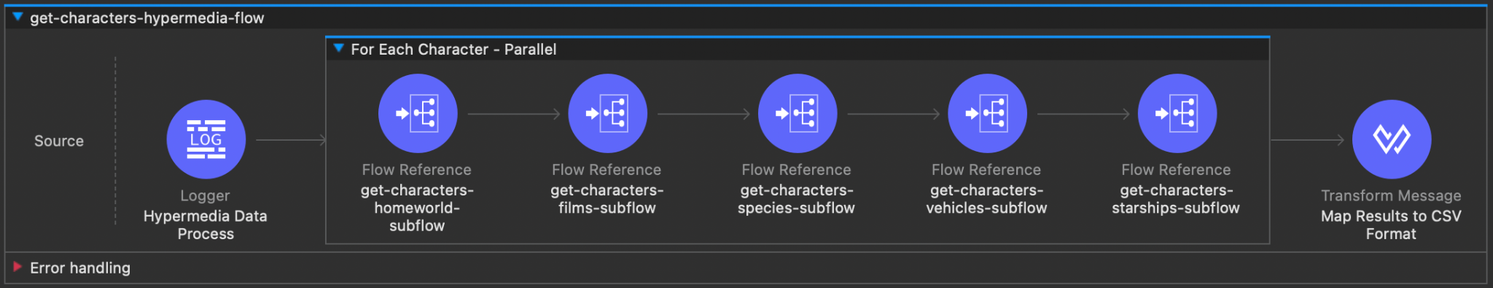

Inside **get-characters-homeworld-subflow:**

* Add a **Choice-Router** to validate if we need to search for the character’s homeworld:
  + If **payload.homeworld** has a URL:
    - Add a logger to print a message to indicate homeworld URL is present and will be called.
    - Add a Transform Message and use the **httpRequest** variable to set the URL homeworld path we need to use. This will replace the previous path defined.
    - Add a Flow-Reference and configure it to call common flow **common-http-request-flow**. This flow reference will use the httpRequest variable updated in the previous step. Add a Target Variable to the flow reference called **characterPlanet** to save only the name needed from the response.
    - Add a Transform Message and use it to replace the current **payload** in iteration by changing the homeworld URL with the name from the **characterPlanet** variable.
  + The **default** route: add a logger to print a message to indicate homeworld is not present.

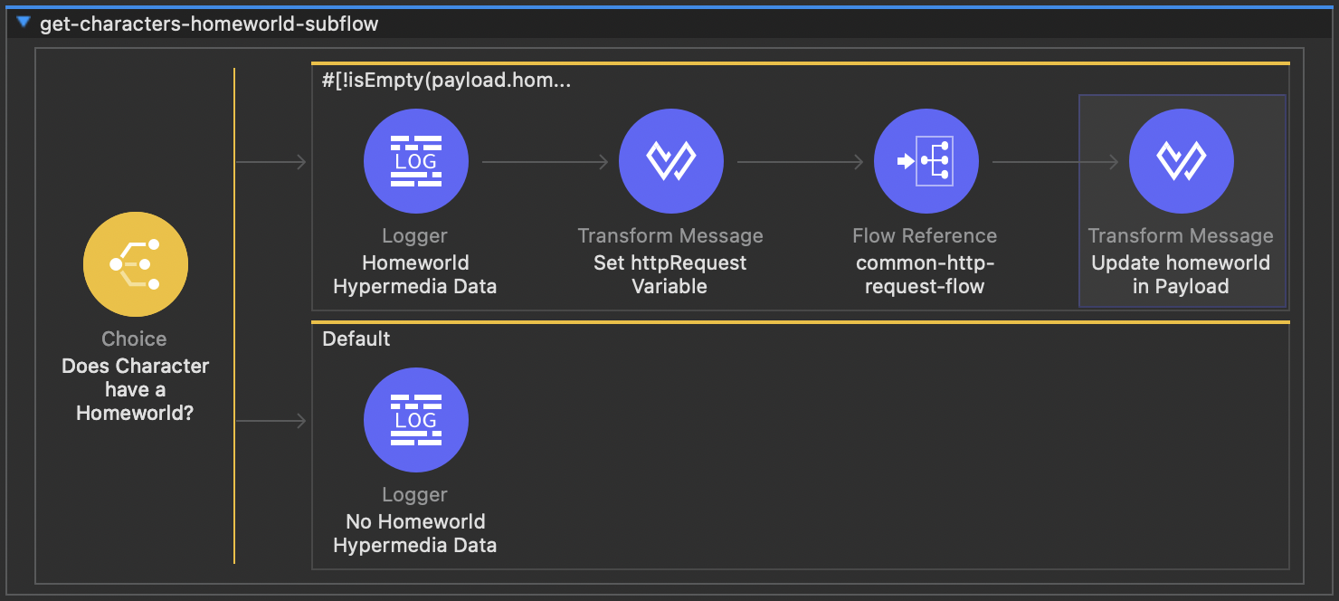

Inside **get-characters-films-subflow:**

* Add a **Choice-Router** to validate if we need to search for the character films:
  + If **payload.films** URLs array is not empty:
    - Add a logger to print a message to indicate film URLs are present and will be called.
    - Add a **Parallel For Each** to iterate **payload.films** and set a Target variable called **characterFilms** to store for each result, inside the scope we will follow the next steps:
      * Add a Transform Message and use the **httpRequest** variable to set the URL film path we need to use. This will replace the previous path defined.
      * Add a Flow-Reference and configure it to call common flow **common-http-request-flow**. This flow reference will use the httpRequest variable updated in the previous step.
    - Add a Transform Message and use it to replace the current **payload** in iteration by changing the film URLs array with the film names from the **characterFilms** variable.
  + The **default** route: add a logger to print a message to indicate films array is empty.

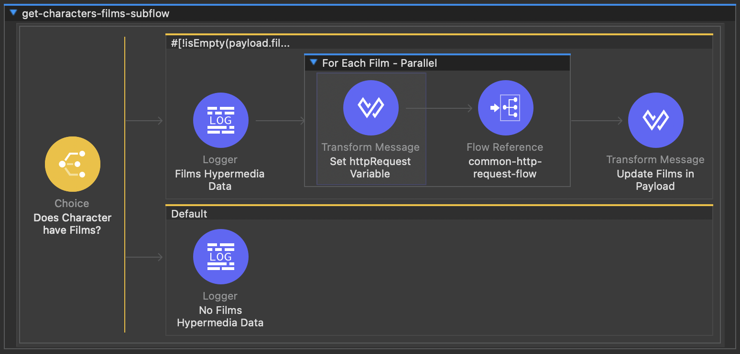

Inside **get-characters-species-subflow:**

* Add a **Choice-Router** to validate if we need to search for the character species:
  + If **payload.species** URLs array is not empty:
    - Add a logger to print a message to indicate specie URLs are present and will be called.
    - Add a **Parallel For Each** to iterate **payload.species** and set a Target variable called **characterSpecies** to store for each result, inside the scope we will follow the next steps:
      * Add a Transform Message and use the **httpRequest** variable to set the URL species path we need to use. This will replace the previous path defined.
      * Add a Flow-Reference and configure it to call common flow **common-http-request-flow**. This flow reference will use the httpRequest variable updated in the previous step.
    - Add a Transform Message and use it to replace the current **payload** in iteration by changing the specie URLs array with the specie names from the **characterSpecies** variable.
  + The **default** route: add a logger to print a message to indicate species array is empty.

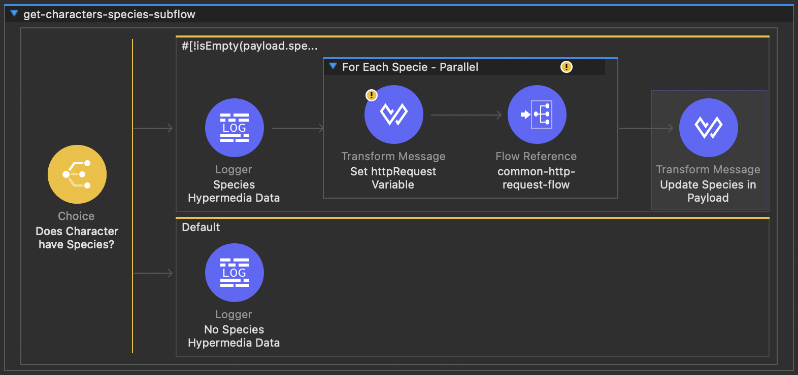

Inside **get-characters-vehicles-subflow:**

* Add a **Choice-Router** to validate if we need to search for the character vehicles:
  + If **payload.vehicles** URLs array is not empty:
    - Add a logger to print a message to indicate vehicle URLs are present and will be called.
    - Add a **Parallel For Each** to iterate **payload.vehicles** and set a Target variable called **characterVehicles** to store for each result, inside the scope we will follow the next steps:
      * Add a Transform Message and use the **httpRequest** variable to set the URL vehicle path we need to use. This will replace the previous path defined.
      * Add a Flow-Reference and configure it to call common flow **common-http-request-flow.** This flow reference will use the httpRequest variable updated in the previous step.
    - Add a Transform Message and use it to replace the current **payload** in iteration by changing the vehicle URLs array with the vehicle names from the **characterVehicles** variable.
  + The **default** route: add a logger to print a message to indicate the vehicle array is empty.

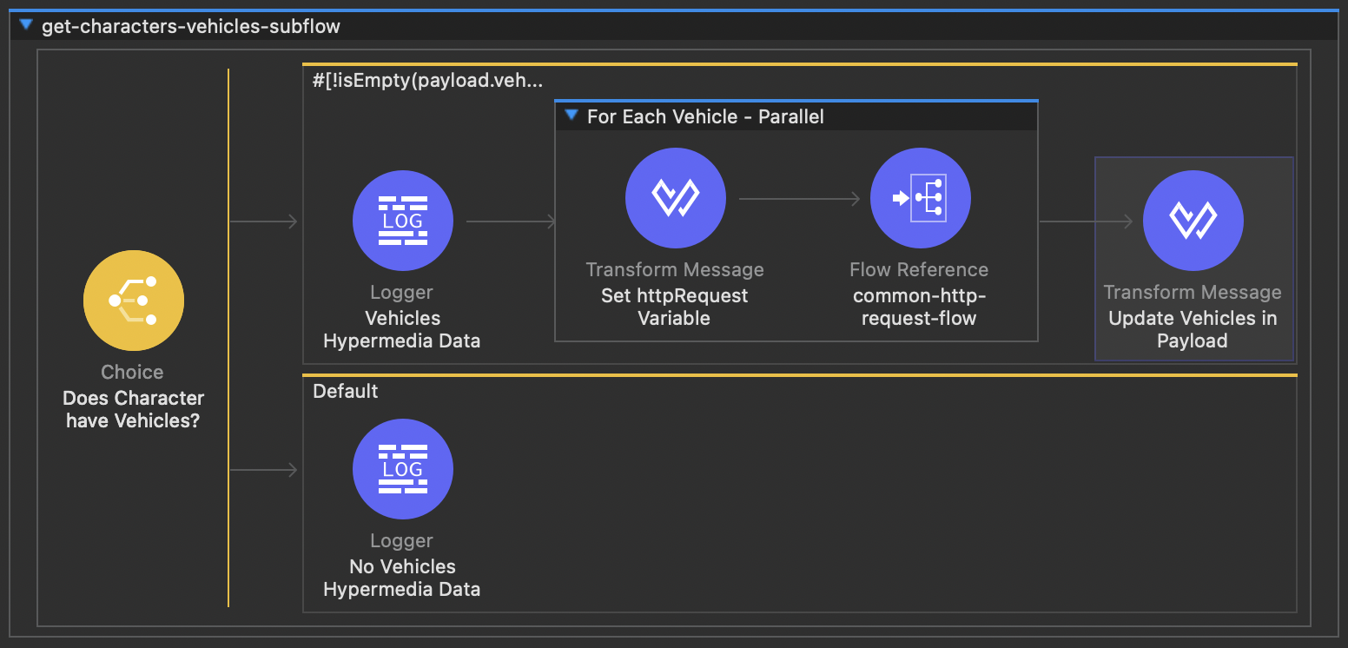

Inside **get-characters-starships-subflow:**

* Add a **Choice-Router** to validate if we need to search for the character starships:
  + If **payload.starships** URLs array is not empty:
    - Add a logger to print a message to indicate starship URLs are present and will be called.
    - Add a **Parallel For Each** to iterate **payload.starships** and set a Target variable called **characterStarships** to store for each result, inside the scope we will follow the next steps:
      * Add a Transform Message and use the **httpRequest** variable to set the URL starship path we need to use. This will replace the previous path defined.
      * Add a Flow-Reference and configure it to call common flow **common-http-request-flow**. This flow reference will use the httpRequest variable updated in the previous step.
    - Add a Transform Message and use it to replace the current **payload** in iteration by changing the starship URLs array with the starship names from the **characterStarships** variable.
  + The **default** route: add a logger to print a message to indicate the starships array is empty.

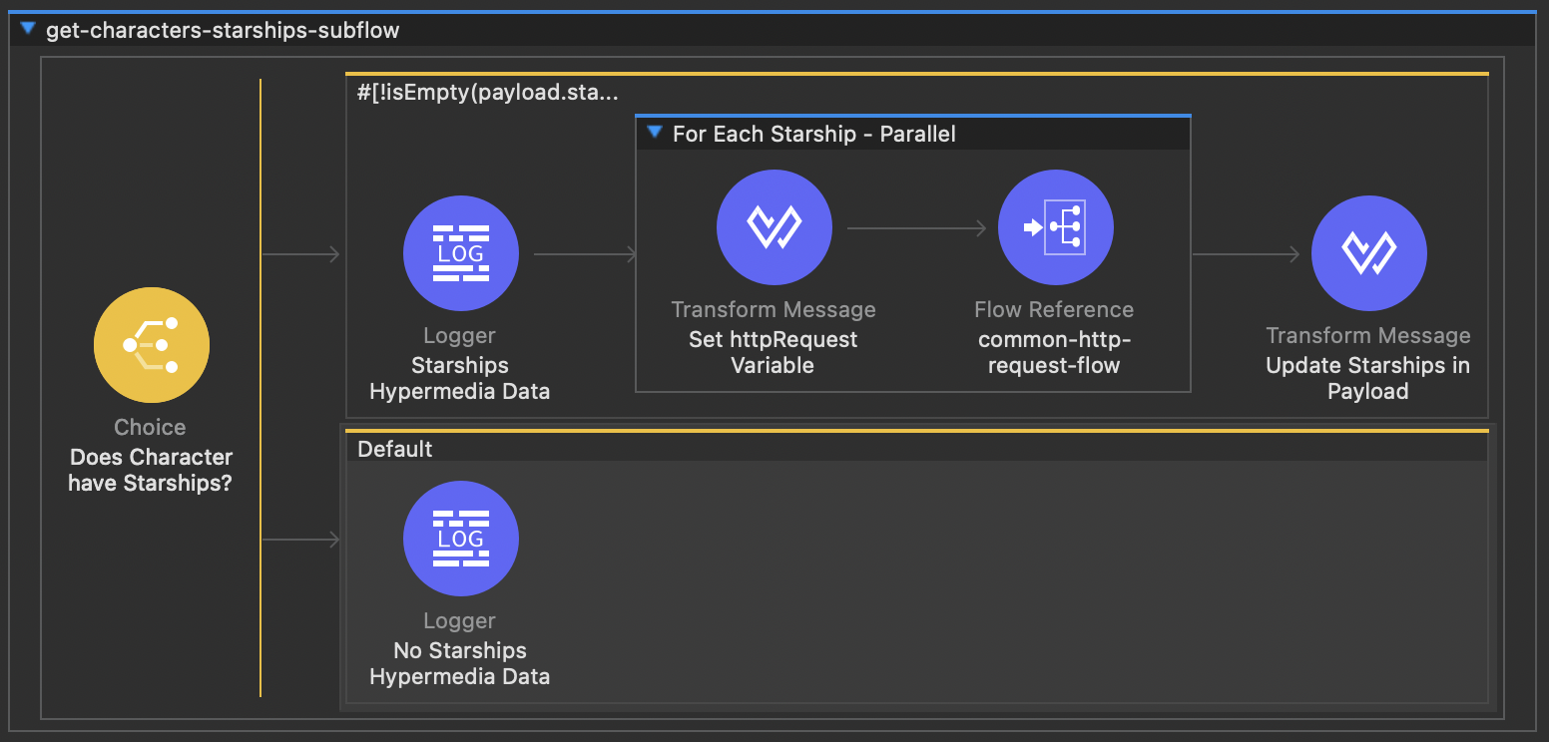

### **Common HTTP Request:**

Create a new file **common-http-request.xml** in the commons folder(create a folder if doesn´t exist)This file will contain the following flows:

* Common-http-request-flow

Inside **common-http-request-flow:**

* Add **HTTP Request** and configure it to work dynamically using the common **httpRequest** variable.
* Create a common **HTTP Request configuration**, you can move this configuration inside the **global.xml** file.

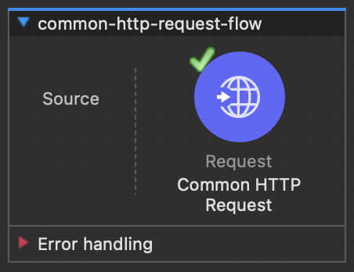

### **Common Error process:**

Create a **common-error-handler.xml** in the commons folder(create a folder if doesn´t exist). This file will contain the following flows:

* Common-error-handler(Error-Handler Component)

Inside **common-error-handler:**

* Set handlers for APIKit errors 400, 404:
  + For each Error Scenario, add a **On-Error-Propagate** to the **Error-handler.**
  + Add a Transform Message and set the **payload** error response.
* Set handlers for HTTP errors 400,404, and 500:
  + For each Error Scenario, add a **On-Error-Propagate** to the **Error-handler.**
  + Add a Transform Message and set the **payload** error response.

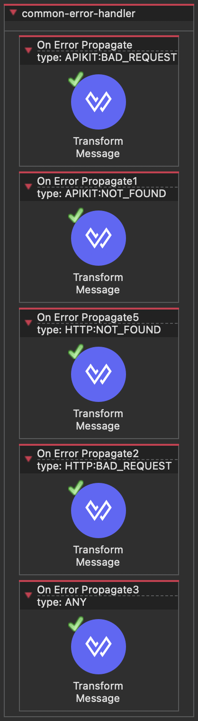

### **SWAPI Response Details:**

| **Response Example** | | | | |
| --- | --- | --- | --- | --- |
| {  "count": 82,  "next": "https://swapi.dev/api/people/?page=2",  "previous": null,  "results": [  {  "name": "Luke Skywalker",  "height": "172",  "mass": "77",  "hair_color": "blond",  "skin_color": "fair",  "eye_color": "blue",  "birth_year": "19BBY",  "gender": "male",  "homeworld": "https://swapi.dev/api/planets/1/",  "films": [  "https://swapi.dev/api/films/1/"  ],  "species": [  "https://swapi.dev/api/films/1/"  ],  "vehicles": [  "https://swapi.dev/api/vehicles/1/"  ],  "starships": [  "https://swapi.dev/api/starships/1/"  ],  "created": "2014-12-09T13:50:51.644000Z",  "edited": "2014-12-20T21:17:56.891000Z",  "url": "https://swapi.dev/api/people/1/"  }  ]  } | | | | |
| **Response Details Mapping - SWAPI to Mule API** | | | | |
| Target System Field | Data Type | Mule Field | Data Type | Defaulting/  Transformation Logic |
| count | Integer | NA | NA | Used to get number pages |
| next | String | NA | NA | Used to validate pagination |
| previous | String | NA | NA | NA |
| results | Array | Payload | Array | Characters results to process. |
| name | String | name | String | Format to CSV |
| height | String | height | String | Format to CSV |
| mass | String | mass | String | Format to CSV |
| hair_color | String | hair_color | String | Format to CSV |
| skin_color | String | skin_color | String | Format to CSV |
| eye_color | String | eye_color | String | Format to CSV |
| birth_year | String | birth_year | String | Format to CSV |
| gender | String | gender | String | Format to CSV |
| homeworld | String | homeworld | String | Get Hypermedia and Format to CSV |
| films | String | films | String | Get Hypermedia and Format to CSV |
| species | String | species | String | Get Hypermedia and Format to CSV |
| vehicles | String | vehicles | String | Get Hypermedia and Format to CSV |
| starships | String | starships | String | Get Hypermedia and Format to CSV |
| created | String | created | String | Format to CSV |
| edited | String | edited | String | Format to CSV |
| url | String | url | String | Format to CSV |